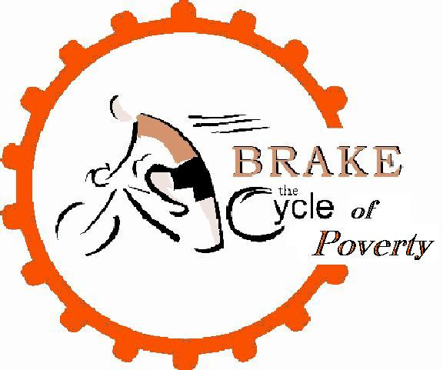
Helping the poor
empower their way
out of
poverty…

Brake the Cycle of Poverty

In July 2003, 8 bikers and 6 support staff from St. Bridget Church in Manchester rode from Manchester, CT to Washington, DC to raise the awareness of poverty, visiting parishes along the way. This ride was part of a national ride called Brake the Cycle of Poverty, sponsored by the Catholic Campaign for Human Development.
The Brake the Cycle of Poverty Team continues to meet with parishes interested in Thinking About, Talking About, and Taking Action against poverty in their local area and in Connecticut.
Learn to PEDAL without having a bike!
Our ongoing mission is to...
- spread awareness of poverty to others
- learn about poverty in Connecticut
- meet people struggling to get out of poverty in Connecticut
- work together to find solutions to poverty in Connecticut
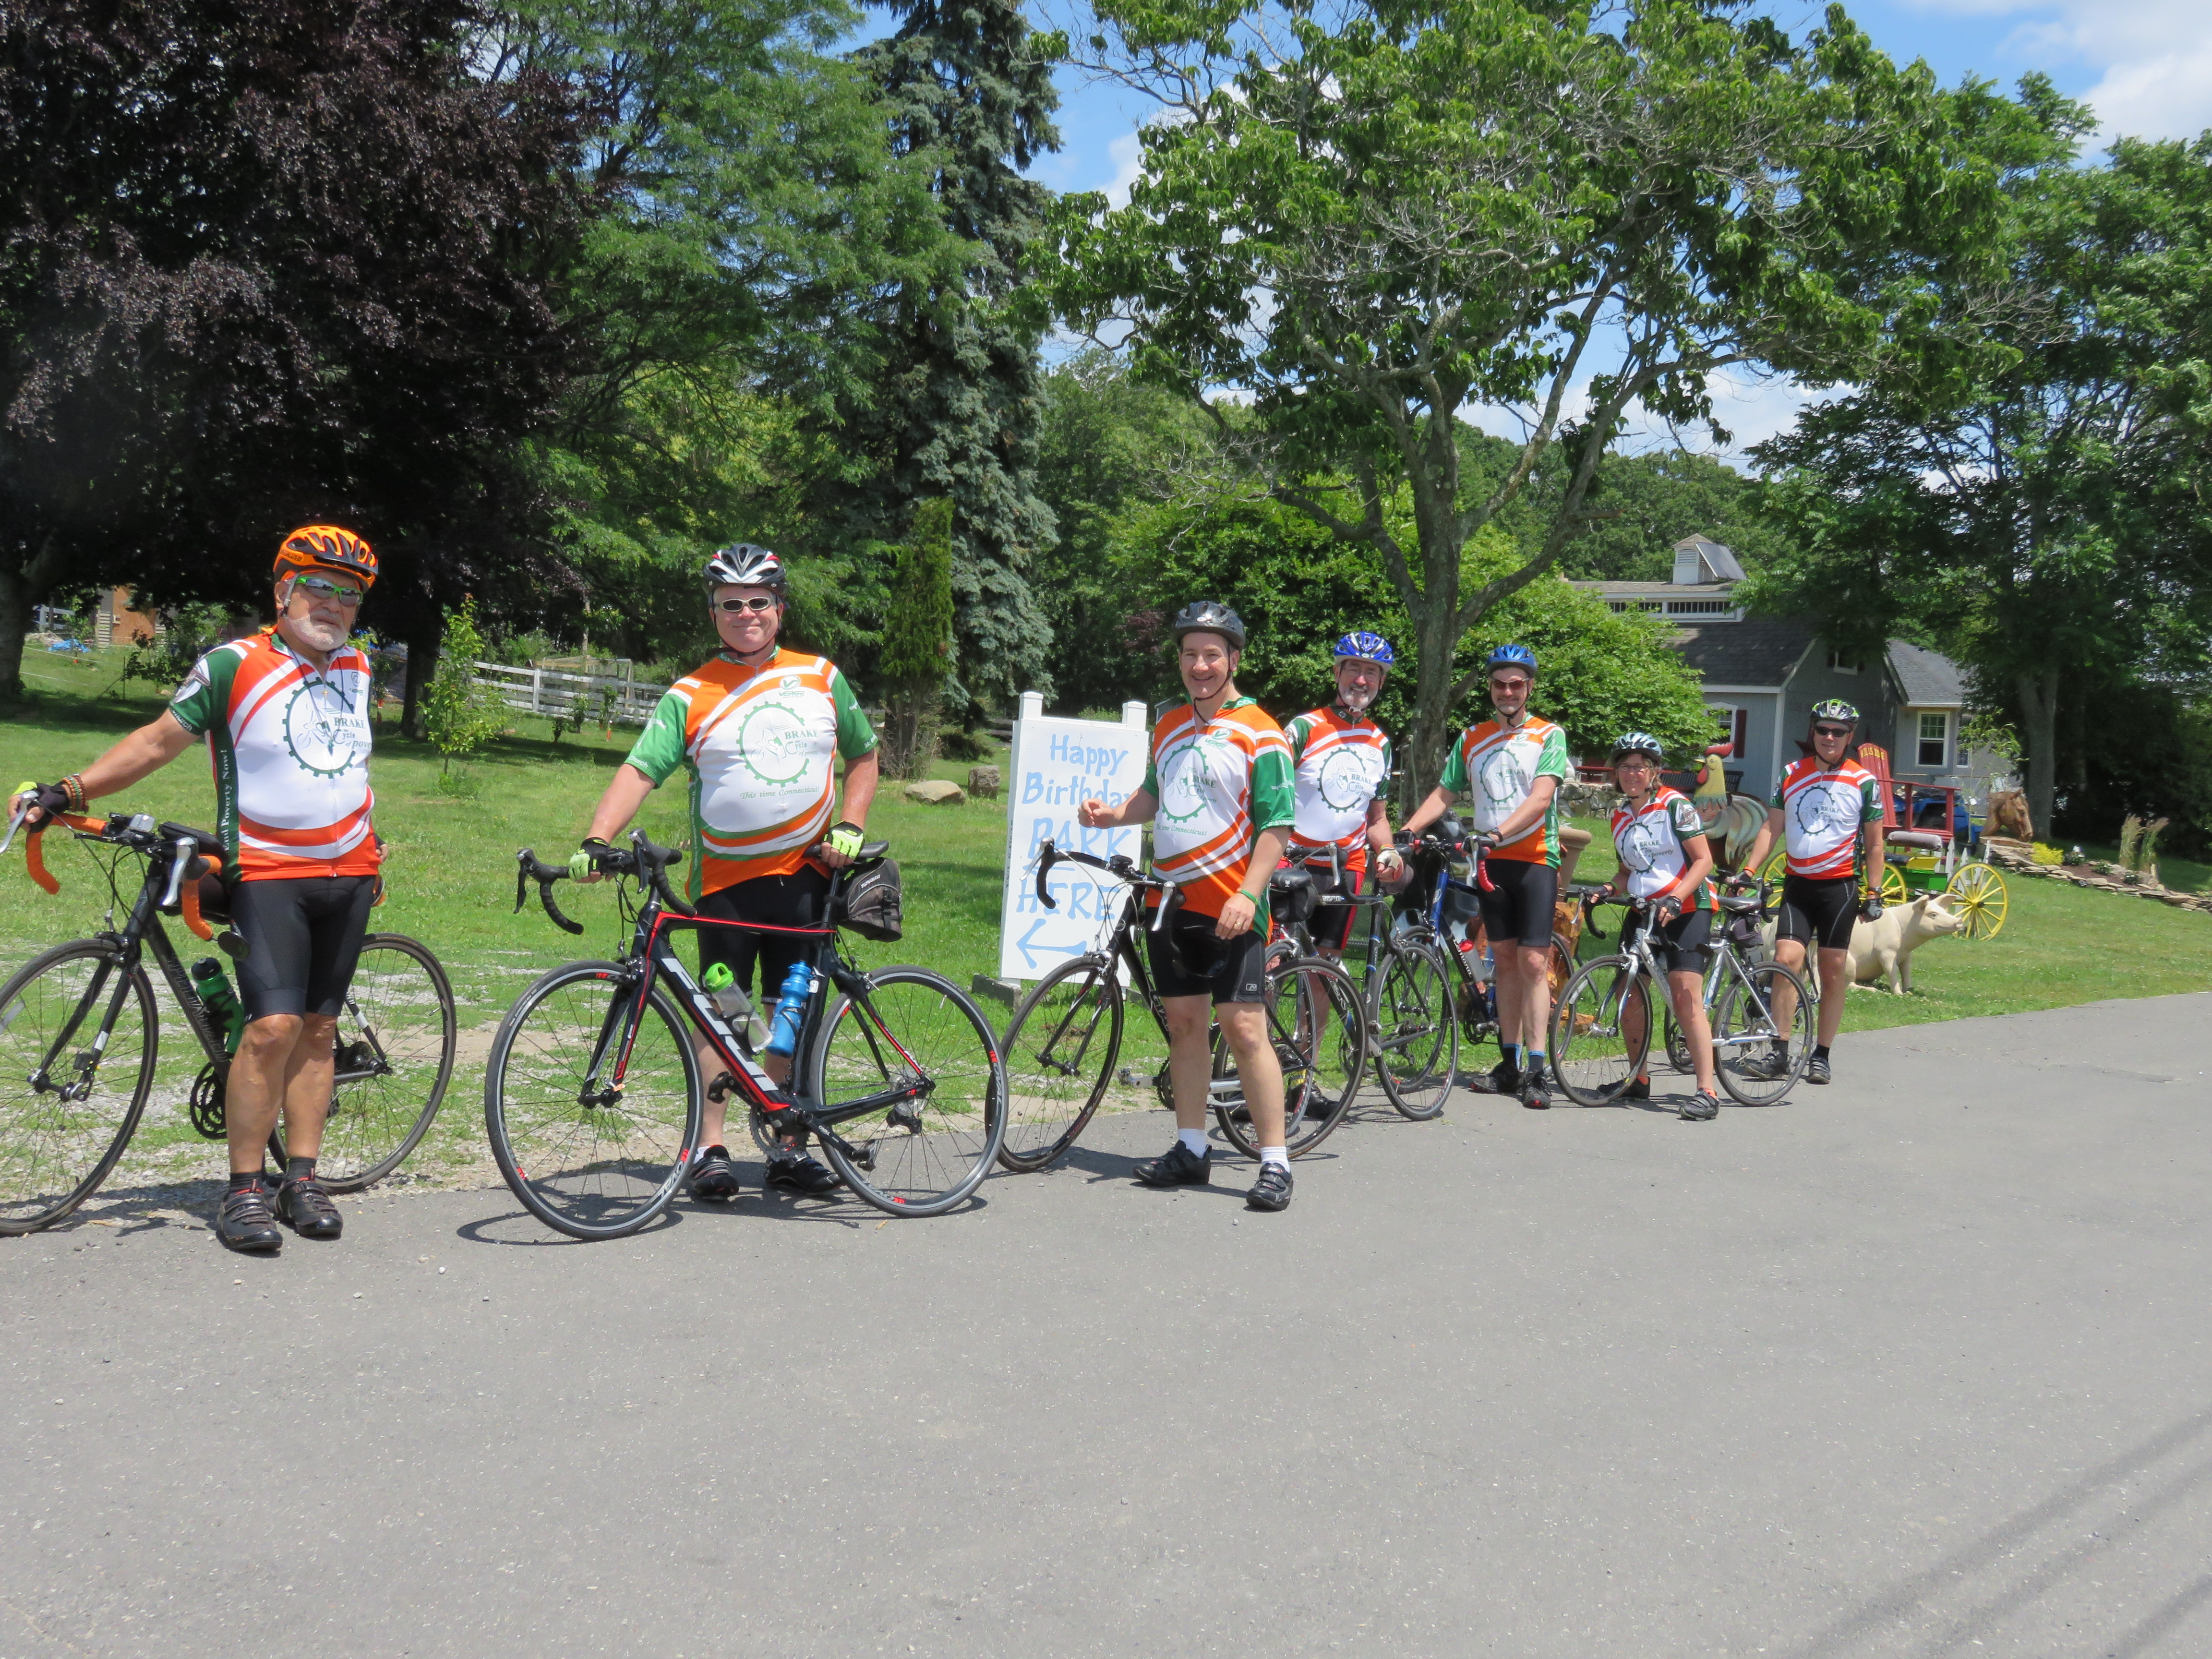
www.brakethecycleofpoverty.org

